1: Develop a lexical Analyzer to identify identifiers, constants, operators using C program.

PROGRAM:

Lexical Analyzer Program:
#include <stdio.h>
#include <ctype.h>
#include <string.h>

int main()
{
int i, ic = 0, m, cc = 0, oc = 0, j;
char b[100];
char operators[30];
char identifiers[30];
int constants[30];

printf("enter the string : ");
scanf("%[^\n]", b);

for (i = 0; i < strlen(b); i++)
{
if (isspace(b[i]))
{
continue;
}
else if (isalpha(b[i]))
{
identifiers[ic] = b[i];
ic++;
}
else if (isdigit(b[i]))
{
m = b[i] - '0';
i++;

while (isdigit(b[i]))
{
m = m * 10 + (b[i] - '0');
i++;
}

i--;
constants[cc] = m;
cc++;
}
else
{
if (b[i] == '*')
{
operators[oc] = '*';
oc++;
}
else if (b[i] == '-')
{
operators[oc] = '-';
oc++;
}
else if (b[i] == '+')
{
operators[oc] = '+';
oc++;
}
else if (b[i] == '=')
{
operators[oc] = '=';
oc++;
}
}
}

printf("\nidentifiers : ");
for (j = 0; j < ic; j++)
{
printf("%c ", identifiers[j]);
}

printf("\nconstants : ");
for (j = 0; j < cc; j++)
{
printf("%d ", constants[j]);
}

printf("\noperators : ");
for (j = 0; j < oc; j++)
{
printf("%c ", operators[j]);
}

printf("\n");

return 0;
}

Sample Output:
Enter the string: a = b + 25 * c + 100

Identifiers: a b c e
Constants: 100
Operators: = + * +

PROGRAM SCREENSHOT:
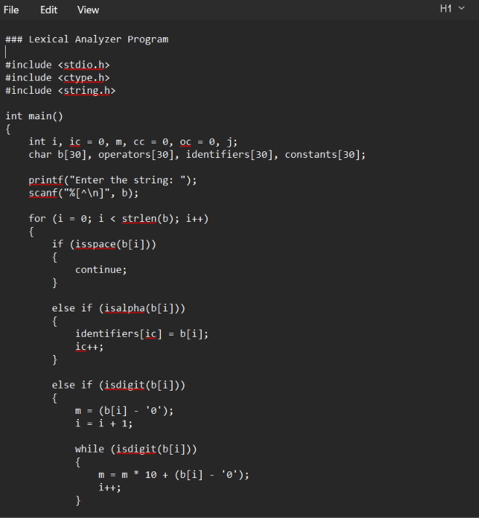
OUTPUT:
